TEC302 – Website Development

Term 3, 2024

**Assessment 2**

**Coding Assignment**

Name: Hardik N Dhorajiya

ID: 1813184

Table Of Contents

1 Introduction 2

2 Design Documents & Prototypes: 2

3 Challenges in Development 5

4 Conclusion 7

5 Reference 8

Description: Coding Assignment

# Introduction

The Gujarati News Channel website is an online platform where people can find the latest news, videos, and updates in the Gujarati language. The website's main goal is to keep the Gujarati-speaking community informed about important news and events. It features news articles, videos, a login section for editors to manage content, and a contact form for users to send feedback or news tips.

The purpose of this website is to make sure the Gujarati community stays updated on what's happening around them and in the world. We want to make it easy for people to read news and watch videos, whether they are using a computer or a mobile phone.

# Design Documents & Prototypes:

Before starting the development of the Gujarati News Channel website, I worked on a few design documents and prototypes to visualize how the website would look and function. This process was essential to ensure that the final product would meet user needs and provide a smooth experience. Below are the steps I followed:

**1. Paper Prototypes:**

I began by sketching the layout of the website on paper. These initial drafts helped me determine the structure and placement of important elements such as:

* A **header** with a logo and navigation menu.
* A **main section** to showcase news, videos, and updates.
* A **footer** with contact details and copyright information.

The paper sketches also helped me outline pages like the login form, contact form, and video gallery.

**2. Digital Prototypes:**

Once the paper sketches were ready, I moved to digital tools like **Figma** and **Adobe XD** to create detailed prototypes. These tools allowed me to design interactive models of the website with actual colors, fonts, and layouts.

Key design decisions in the digital prototypes included:

* **Color Scheme:** A professional combination of blue and white to maintain readability and reflect trustworthiness.
* **Typography:** Clean and simple fonts like Arial to ensure text is easy to read.
* **Responsiveness:** The design was tailored to adjust automatically for various devices, including desktops, tablets, and mobile phones.

**Prototype Highlights:**

1. **Homepage Layout:**
   * Featured a navigation bar at the top for easy access to different sections like "Home," "Videos," "Login," and "Contact Us."
   * The main section displaying the latest news headlines as clickable links.
2. **Video Gallery:**
   * A grid layout to showcase embedded YouTube videos.
   * Each video was accompanied by a short description.
3. **Login Page:**
   * A simple form with fields for a username and password.
   * A message area to show success or error messages based on the login attempt.
4. **Contact Page:**
   * Included fields for name, email, and a text box for users to submit feedback or news tips.
   * A "Submit" button styled to match the website's overall design.

Here are some screenshots of the design prototypes:

# Challenges in Development

While building the website, I faced a few challenges. Here are some of the main ones:

1. **Making the Website Work on All Devices:** One of the biggest challenges was making sure the website looks good and works well on both computers and mobile phones. To solve this, I used something called "responsive design," which adjusts the layout based on the size of the screen. I had to test and tweak the website to make sure it looked good on different screen sizes.

1. **Making It Work on Different Browsers:** I also needed to make sure the website works well on different web browsers, such as Google Chrome, Firefox, and Microsoft Edge. Sometimes, some elements (like videos and buttons) didn’t display the same way on all browsers, so I had to make some changes to fix that.

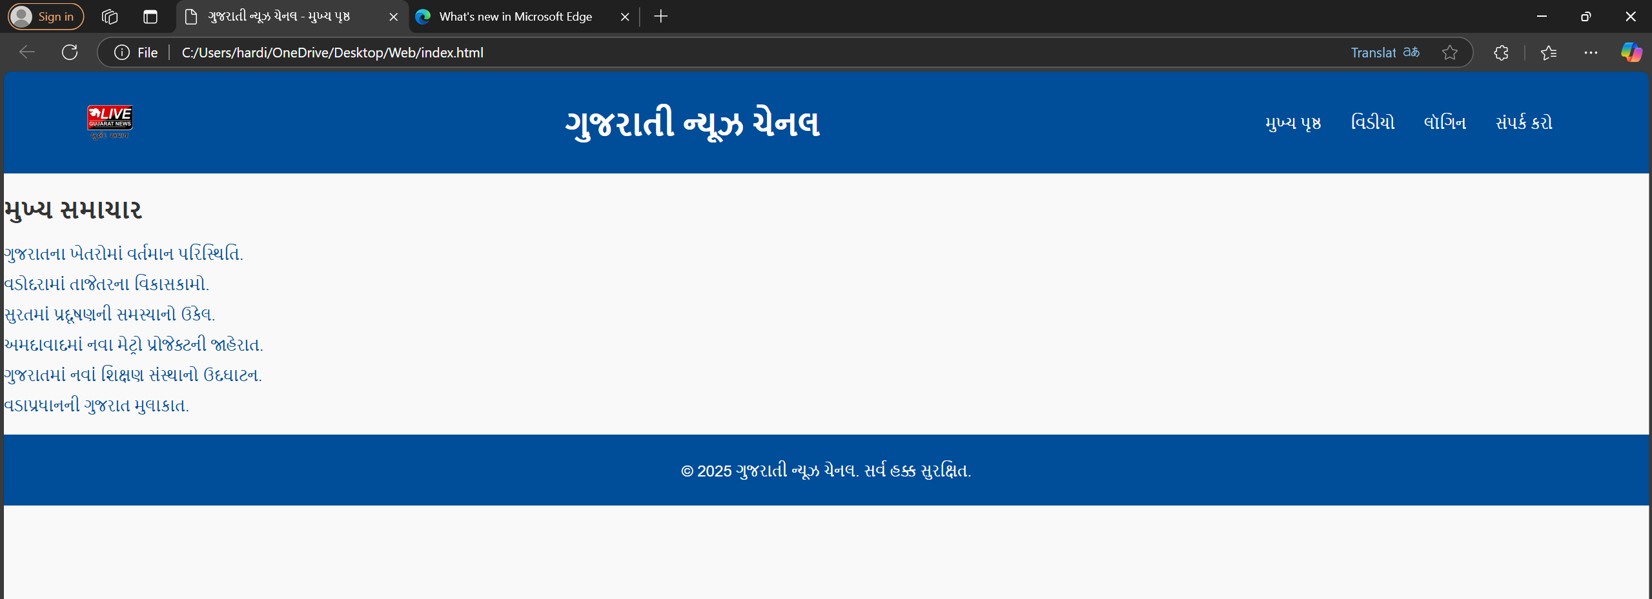

1. **Fixing Bugs and Errors:** During development, I had to debug (fix) issues that came up. For example, the login form wasn’t showing an error message when someone entered the wrong username or password. I also had to fix a problem where videos didn’t resize properly. It took some time, but I was able to fix everything.

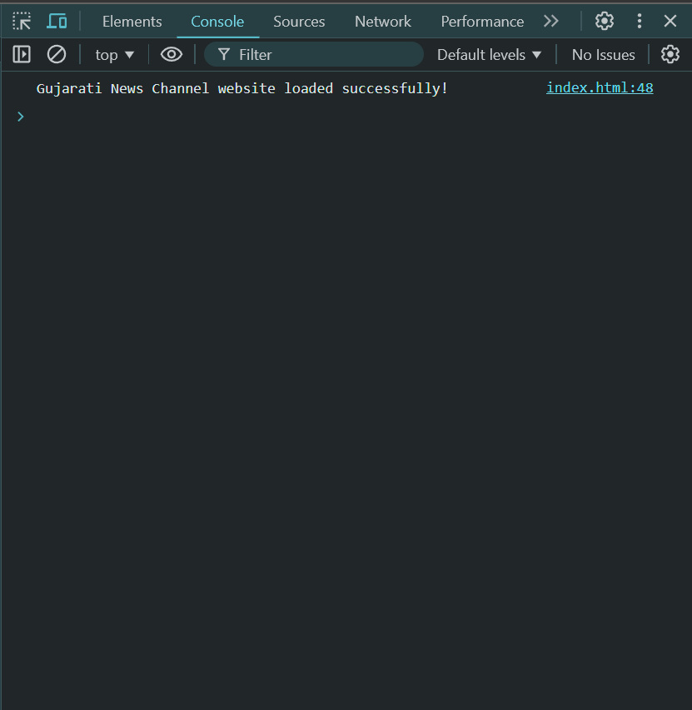

1. **Login Feature:** The website has a login form for editors to add and manage content. At first, this was just a simple form to test how it would work. In the future, I plan to connect it to a system where user data is stored securely .but currently data security was not my concern because this was just an assessment at university level.

1. **Ensuring Everything Works Smoothly:** After building the website, I tested everything to make sure it worked properly. I had to check that the news and videos showed up correctly, and that users could submit their feedback without problems. Even after the website is launched, I will keep testing and fixing any problems that come up.

# Conclusion

I had great fun while designing the website for Gujarati News Channel and it was quite enlightening. The website was developed to allow users to access or read the latest news, watch videos and directly get in touch with the team through the contact form. Thus, keeping user needs in mind and designing a responsive site layout was the strategy that I wanted to accomplish with the site design laid out in front of me. There were several critical stages in the development process such as the layout planning, prototyping, coding the functionality and other. Debugging errors, a need to be certain that the application responds properly across the different screen sizes also had their merits as learning processes. Such difficulties reminded that it is crucial to test and redesign to get a workable and functional website.

I was able to go from an idea, on paper with pencil and eraser, to a digital mock up of index cards too as well as using modern web development frameworks to make this site live. I also incorporated use of artificial intelligence aid in bug checking and correcting details on the project to meet set technical quality and usability standards.

In the sum, this project achieved its objective of developing a web platform for watching and reading the Gujarati news while improving my knowledge of website design and development. All in all, the website could have been created and implemented only thanks to the correct planning, imagination, and hard work.

# Reference

*Responsive web design tips* (no date) *ChatGPT*. Available at: https://chatgpt.com/share/678e171c-bdb8-800d-aa9f-06c1d9a858c4 (Accessed: 18 January 2025).

(No date) *Wikimedia Commons*. Available at: https://commons.wikimedia.org/wiki/File: Live_Gujarat_News_Logo.png (Accessed: 15 January 2025).

(No date a) *YouTube*. Available at: https://www.youtube.com/ (Accessed: 19 January 2025).